**PUBLISHED DATE: - 16-09-2024**

**DOI: -** <https://doi.org/10.37547/tajas/Volume06Issue09-03> **PAGE NO.: - 12-16**

**RESEARCH ARTICLE Open Access**

**ANGREN SECONDARY KAOLINITE CLAYS IN THE PRODUCTION OF ALUMINOSILICATE PROPPANTS**

**Bayraeva Nasiba Ashurbayevna**

PhD student, Institute of General and Inorganic, Chemistry of Academy of Sciences of the Republic of Uzbekistan

**Khomidov Fakhriddin Gafurovich**

PhD, Institute of General and Inorganic Chemistry of Academy of Sciences of the Republic of Uzbekistan, Tashkent, Uzbekistan

**Adizov Bobirjon Zamirovich**

Doctor of Chemical Sciences, Prof. Institute of General and Inorganic, Chemistry of Academy of Sciences of the Republic of Uzbekistan

**Abstract**

The article presents the results of studying the chemical-mineralogical and physical-mechanical characteristics of Angren secondary kaolin and kaolinite clay and their suitability for obtaining aluminosilicate proppants. It was found that the melting point of Angren secondary kaolin is 1540 ° C and the compressive strength in the fired at a temperature of 1400 ℃ reaches up to 105 MPa, and for kaolinite clay these indicators showed 1505 ℃ and 109 MPa, respectively. The obtained indicators suggest that these clay materials can be used as the main component for obtaining aluminosilicate proppants.

**KEYWORDS:** kaolin, proppant, kaolinite, phase transformations, X-ray analysis, crystal structure, mullit.

# INTRODUCTION

# Proppant is a granular, wedging material used in the oil industry to improve the efficiency of wells using hydraulic fracturing (HF) technology. It serves to maintain the permeability of cracks obtained during HF. It is granules of similar size, with a typical diameter of 0.25 to 2.5 mm [1, 2].

# The physical characteristics of proppants that affect fracture conductivity include parameters such as strength, size and shape of granules, particle size distribution, presence of impurities, solubility in acids, and density [3].

# Ordinary quartz sand, artificially synthesized on the basis of the mineral bauxite and obtained on the basis of aluminosilicate compounds, is used as proppants [4].

# Recently, proppants have been synthesized based on various natural raw materials and waste [5]. Among them, proppants synthesized based on kaolin raw materials are characterized by a density close to ordinary quartz sand, higher strength compared to sand and cheaper than proppants obtained based on bauxite.

# Taking this into account, this article studies the physicochemical and technological properties of Angren secondary kaolin and kaolinite clays in order to determine the possibility of their use for obtaining aluminosilicate proppant.

# METHODS

# The material composition of kaolin samples was determined by the method of silicate chemical analysis using the accelerated method [6]. The mineralogical composition of basalt samples was determined by X-ray phase analysis, which was carried out by the powder method on a Shimadzu LABX XRD-6100 X-ray diffractometer with CuKα radiation. Identification of mineral phases and analysis of the results were carried out using reference books and the generally accepted ICDD PDF-2 database [7, 8].

# RESULTS AND DISCUSSION

# In the republic, geological reserves of kaolinite clays are located at the Angren deposit of brown coal, refractory clay and kaolin, where the recorded reserves of secondary kaolin in this area are about 350 million tons [9, 10]. The volumes of industrial reserves of secondary kaolin and kaolinite clay make it possible to select it as a raw material component for the production of aluminosilicate proppants. Table 1 shows the results of chemical analysis of secondary kaolin and kaolinite clay.

**Table 1**

**Chemical compositions of the samples under study**

|  |  |  |  |  |  |  |  |  |  |
| --- | --- | --- | --- | --- | --- | --- | --- | --- | --- |
| Name of raw  material | Oxide content, wt.% | | | | | | | | LOI, wt.% |
| SiО2 | Аl2O3 | Fе2O3 | CaO | MgO | Na2O | K2O | SO3 |
| Angren secondary kaolin | 66,31 | 19,37 | 1,29 | 1,67 | 0,23 | 0,52 | 0,81 | 0,17 | 9,63 |
| Kaolinite clay | 53,48 | 24,89 | 5,91 | 1,12 | 1,11 | 1,09 | 1,02 | 1,24 | 10,14 |

# The results of chemical analysis showed that the content of Al2O3 in Angren secondary kaolin is 19.37 wt.%, and in kaolinite clay - 24.89 wt.%. It should be noted that kaolinite clay is distinguished by the fact that the content of iron oxide is higher than that of secondary kaolin (5.91 wt.%).

# In order to study the change in the oxide content in the chemical compositions of the initial raw materials, heat treatments were carried out at 1000℃ with a holding time of 60 min. The results obtained are given in Table 2.

**Table 2**

**Chemical compositions of the studied samples, in terms of**

**calcined substance**

|  |  |  |  |  |  |  |  |
| --- | --- | --- | --- | --- | --- | --- | --- |
| Name of raw  material | Oxide content, wt.% | | | | | | |
| SiO2 | Al2O3 | Fe2O3 | MgO | CaO | Na2O | K2O |
| Angren secondary kaolin | 73,51 | 21,47 | 1,43 | 1,85 | 0,25 | 0,58 | 0,90 |
| Kaolinite clay | 60,35 | 28,09 | 6,67 | 1,26 | 1,25 | 1,23 | 1,15 |

# The results show that after heat treatment at 1000℃ with a holding time of 60 min, an increase in silicon and aluminum oxides is observed for Angren secondary kaolin to 73.1% (SiO2) and 21.47% (Al2O3), and for kaolinite clay to 60.35% (SiO2) and 28.09% (Al2O3) respectively.

# The phase composition of the test samples was determined by X-ray analysis. The results of the X-ray phase analysis are shown in Fig. 1.

# X-ray phase analysis of the kaolinite clay samples (Fig. 1a) shows that this clay mainly contains diffraction maxima related to the minerals kaolinite d=0.718; 0.445; 0.337; 0.279; 0.256; 0.249; 0.234; 0.228; 0.199; 0.173; 0.167 nm and quartz with diffraction lines d= 0.425; 0.334; 0.245; 0.228; 0.223; 0.212; 0.198; 0.181; 0.154 nm, and lines with less intensity related to the mineral hematite d=0.268; d=0.249; d=0.167 nm.

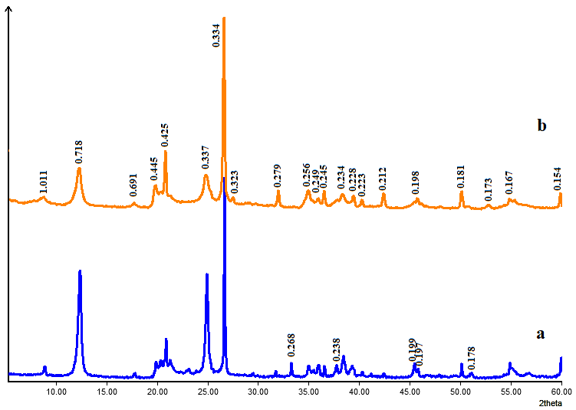

**Fig. 1. X-ray diffraction patterns of the studied samples:**

1. kaolinite clay; b) Angren secondary kaolin

# The X-ray diffraction pattern of the Angren secondary kaolin sample (Fig. 1b) also revealed diffraction maxima related to the minerals kaolinite and quartz, as well as a small amount of the mineral feldspar (d=0.323; d=0.245) and muscovite (d=1.011; 0.498 nm).

# It is known that the sintering and melting temperatures of raw materials are affected by the material, chemical and mineralogical compositions, structures and their other physical and chemical characteristics. It should be noted that, especially when developing ceramic masses for obtaining aluminosilicate proppants, the temperature of the end of sintering and the beginning of melting, as well as physical and mechanical characteristics, are of particular importance.

# In this regard, the temperature of the beginning and end of melting of raw materials, as well as their physical and mechanical characteristics after firing at a temperature of 1400℃, were determined. The results obtained are given in Table 3.

**Table 3**

**Temperatures of the beginning and end of melting of samples, and their physical and mechanical characteristics when fired at 1400℃**

|  |  |  |  |  |  |
| --- | --- | --- | --- | --- | --- |
| Name  samples | Melting point, ℃ | | Temperature range, ℃ | Compressive strength, MPa | Mohs hardness |
| Begin | End |
| Angren secondary kaolin | 1540 | 1610 | 50 | 105 | 7 |
| Kaolinite clay | 1505 | 1580 | 65 | 109 | 7 |

# The obtained results showed that the temperatures of the beginning and end of melting of Angren secondary kaolin are 1540 and 1610 °C, respectively, and kaolinite clay 1505 and 1580 °C. At the same time, the compressive strength in the fired at a temperature of 1400 °C reached 105-109 MPa.

# CONCLUSION

# Thus, the chemical-mineralogical and physical-mechanical characteristics of Angren secondary kaolin and kaolinite clay and their suitability for obtaining aluminosilicate proppants were studied. It was found that the melting point of Angren secondary kaolin is 1540℃ and the compressive strength at a temperature of 1400℃ reaches up to 105 MPa, and for kaolinite clay these indicators showed 1505℃ and 109 MPa, respectively. According to these indicators, it is assumed that these clay materials can be used as the main component for obtaining aluminosilicate proppants.

# REFERENCES

# Yatsenko E. A., Chumakov A. A., Tretyak A. A. The influence of the addition of slag waste from the Novocherkassk SDPP on the properties of aluminosilicate materials based on drill wastes from the Vostochno-Chumakovskoye oil field. Steklo i keramika. 2024. No.97(07). P.29-34.

# Pauliukevich Yu. G., Laryionov P. S., Kavrus I. V. Influence of structural factors on the mechanical strength of glass-ceramic propants. Steklo i keramika. 2023. No.96(1). P.22-27.

# Reshetova A.A., Alferova A.I. Use of kaolins of the Ural-Siberian region in the technology of ceramic aluminosilicate proppants. Proceedings of the XIV International scientific and practical conference of students and young scientists "Modern equipment and technologies". Tomsk - 2008. Tomsk: TPU Publishing House. 2008. P.156-157.

# Vakalova T.V., Reshetova A.A., Pogrebenkov V.M., Vereshchagin V.I. Activation of the process of mullite synthesis and sintering of aluminosilicate ceramics based on refractory clay raw materials. Refractories and technical ceramics. 2009. No. 7 - 8. P. 74 - 80.

# Abdrakhimova E.S., Abrakhimov A.V., Abdrakhimov V.Z. Polymorphic transformations of Si02 in clay materials of different chemical and mineralogical composition. Materials Science. 2002. No. 7. P. 35 - 41.

# GOST 26423-86. Refractory materials and products. Methods for determining silicon dioxide.

# Kutsevol M.L. X-ray method of diagnostics and qualitative phase analysis of minerals. Practical guide to laboratory work in the discipline “Laboratory methods for studying minerals.” Dnepropetrovsk 2012. P. 35p.

# ASTM Standards Part 17. “Refractories, Glass, Ceramic Materials, Carbon and Graphite Products” ASTM. Philadelphia. 2005. P. 7-9, 51-61.

# Kadirova Z.R., Eminov A.M., Hujamberdiev M.I., Boyjanov I. Prospective Kaolins in Uzbekistan. Tile & Brick International. 2003. Vol.19. No.4. P.252-257.

# Eminov A.M., Sabirov B.T., Negmatov S.S., Sargsyan A.S., Kadyrova Z.R. Physicomechanical studies of new kaolins in the production of aluminosilicate composite ceramics. Composite materials. Publ. GUP "Fan va tarakkiyot", Tashkent. 2016. No. 4. P. 24-30.

# Eminov A.M., Kadyrova Z.R., Sarkisyan O.S., Hujamberdiev M.I. Kaolin «Alliance»-new ceramic raw material. I Investigation of chemical-mineralo-gical composition. DVS – Verlag CmbH (Germany). 2004. No11. Р 72-75.